**Software Requirements**

**Specification**

**for**

**Asia Pacific College Student Assistant System**

**Version 1.0 approved**

**Prepared by Abrera, Jenna Ann B.**

**Cruz, Lorenz Matthew M.**

**Romero, Jun Kimuel C.**

**Tomas, Gener Joseph G.**

**Student Assistant – Discipline Office November 28, 2016**

# Table of Contents

Table of Contents 2

Revision History 3

1. Introduction 1

1.1 Purpose 1

1.2 Document Conventions 1

1.3 Intended Audience and Reading Suggestions 1

1.4 Product Scope 1

1.5 References 1

2. Overall Description 2

2.1 Product Perspective 2

2.2 Product Functions 2

2.3 Operating Environment 2

2.4 Design and Implementation Constraints 3

2.5 User Documentation 3

2.6 Assumptions and Dependencies 3

3. External Interface Requirements 4

3.1 User Interfaces 4

3.2 Hardware Interfaces 5

3.3 Software Interfaces 5

3.4 Communications Interfaces 5

4. System Features 5

4.1 User logs into the system 5

4.2 Employee creates request for student assistants 5

5. Other Nonfunctional Requirements 6

5.1 Performance Requirements 6

5.2 Safety Requirements 6

5.3 Security Requirements 6

5.4 Software Quality Attributes 6

5.5 Business Rules 6

Appendix A: Glossary 7

Appendix B: Analysis Models 8

# Revision History

|  |  |  |  |
| --- | --- | --- | --- |
| **Name** | **Date** | **Reason For Changes** | **Version** |
| Abrera | November 28, 2016 | Document created and new entries for Software Requirements Specification | 1.0 |
| Cruz | November 28, 2016 | Filled-up new entries for Software Requirements Specification | 1.1 |
| Romero | November 29, 2016 | Updates entries for Software Requirements Specification | 1.2 |
| Tomas | November 30, 2016 | Filled-up missing parts for Software Requirements Specification | 1.3 |

# Introduction

## Purpose

The purpose of our system will help to improve the productivity in Student Assistance. It will help the users to lessen the things to do in terms of rendering SA hours. The SA is for those students that have a scholarship from Catholic, SFA (Socialized Financial Assistance), Public Schools and scholarship that must be 50% and above to serve as S.A. or Student Assistant. For Those students who have 50% and above they’re required to serve as S.A. meaning they help in the operations of service offices and they’re also required to render 15 hours per term and if they didn’t render that 15 hours per the remaining time will be carried till next term until you completed that hours’ task.

## Document Conventions

None.

## Intended Audience and Reading Suggestions

**Student Assistant Supervisor**   
The only user who can view all information but no access to edit.   
  
**Registrar**   
The user who provides the lists of student with scholarships   
  
**Office Coordinator**   
The user who provides office availability for the SA   
  
**Discipline Office Head**   
They assign SA to offices.   
They review the SA request form filled up by the students.   
Can view the verified time rendered by office coordinator of a SA.   
  
**Departmental Coordinator**   
 Request for S.A. students   
Comment to the students   
  
**Student Assistants**   
Fills up request form and time render form.   
See how many time left to finish the 10hrs per term

## Product Scope

We aim to develop the Student Assistant (SA) Management at APC. They have one term of operation which is the manual system. We will provide an intranet based system for the Student Assistant Management which it can help the SA by providing them the opportunity of a faster operation.

## References

None.

# Overall Description

## Product Perspective

The Student Assistant System would be a major improvement to the Discipline Office in keeping track of the records of Student Assistants (SA) and also the time that have been rendered for each term. The Discipline Office’s operation is manual system. A SA is under close supervision and in a learner capacity, to assist in the performance of the duties required by the departmental assignment. SA’s help in the operations of the office per each department.

## Product Functions

* Keep track of records and the hours rendered for each SA.
* Able to request for SA for a certain office department.
* SA’s are able to reserve for a specific department.
* Ability to generate reports.
* Filter Student Assistants from the list of provided students enrolled in a given term.

## Operating Environment

**Programming Languages**

* PHP
* HTML5
* MySQL

**Specific Software**

* phpMyAdmin
* Web Server Application
* Apache
* MySQL
* Yii2

**Operating System**

* Windows 7, Windows 8, Windows 10

**Other Software/Applications**

* XAMPP
* Notepad++
* Browser (Mozilla Firefox, Google Chrome)

## Design and Implementation Constraints

Since the project is intended to be implemented alongside the current working intranet-based system of Asia Pacific College, the UI and design should be in the same format as the current working system. Because the system would be integrating some parts of the school’s data architecture, it would need to be tested if the parts created would work seamlessly with the data architecture before it could be released for the usage of SA affairs.

## User Documentation

A. Running System / Research Paper

B. Project's Wiki

C. Project Github

D. Project / Research Status / Progress Status

E. Vision and Scope Document

F. Project Plan / Project Statement of Work / Project Risk Plan

G. Work Breakdown Structure / Activity List / Gantt Chart

H. Software Requirements Specification

I. Change Management Plan

J. Quality Plan

K. User / Admin Manuals

L. UML Diagrams

## Assumptions and Dependencies

Since we have no direct control on the databases and Flavio backend, we can only make assumptions based on the architecture of the tables they have provided for us. These constraints could prove a problem when they are in the integration phase of the system to the current running intranet service, but the system should be able to work in the virtual environment we have provided.

# External Interface Requirements

## User Interfaces

Cobalt Framework

**Sample Screenshot:**

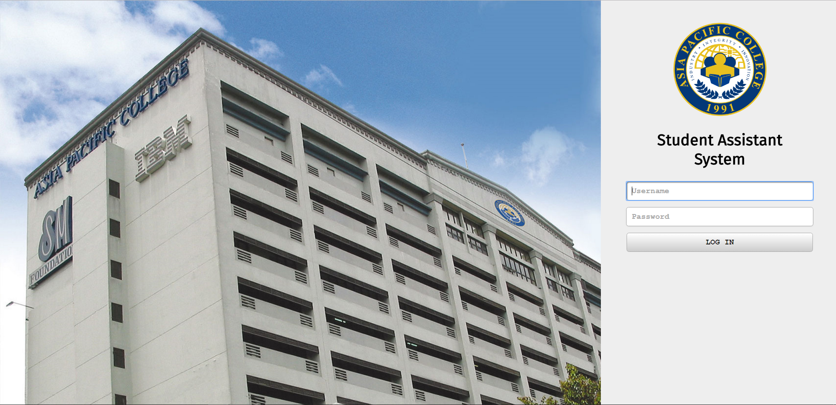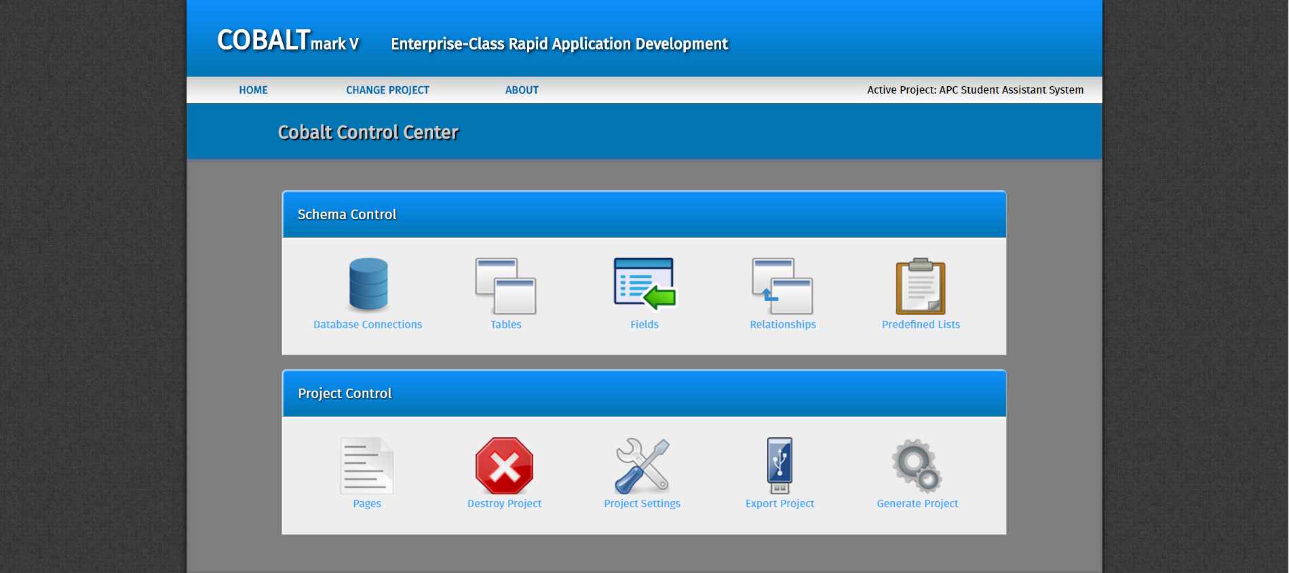

## Hardware Interfaces

This system is an intranet-based web application, any device that can access thru the internet of the school can also access this in Flavio. Since this web application is created in cobalt the Graphical User Interface (GUI) of this framework is look like Flavio.

## Software Interfaces

In the locally hosted version of the application, it will need to utilize aspects of XAMPP, namely the apache and PHPMyAdmin features. Since the application will be developed using the Cobalt framework latest released version (Cobalt mkV 2016-10-27) utilizing the PHP programming language, it would need to utilize the PHP components available in the XAMPP program package to be able to run the application.

## Communications Interfaces

Since the system will run thru an intranet-based web application this system is only accessible within the school facilities connected to the school’s network. This system will be access in any modern browser and given that the system is running locally, data transfer rates will not necessarily be an issue.

# System Features

## User logs into the system

4.1.1 Description and Priority

This system allows users to log-in and log-out of the system.

4.1.2 Stimulus/Response Sequences

* User logs-in through mobile app or web browser
  + System verifies account that requested a log-in
  + System logs in existing user
  + System displays landing page to the user
* User logs-out of the system
  + System removes access to user
  + System displays index page to the user

4.1.3 Functional Requirements

REQ-1: There must be an existing user account in the system.

## Employee creates request for student assistants

4.1.1 Description and Priority

An employee per department may create an announcement for the reservation of student assistants for their department.

4.1.2 Stimulus/Response Sequences

* Employee creates announcement
  + System displays office availability and the no. student assistants needed.

4.1.3 Functional Requirements

REQ-1: User must be an employee with a user type of a department coordinator or student assistant head.

# Other Nonfunctional Requirements

## Performance Requirements

Since there’s a chance of experiencing down of the system, no internet connection or slow connection, there’s a possibility that you cannot input the needed information on your user account, you can just take down notes for the mean time so you won’t able to forget it and just input the data if the system doesn’t have any problem anymore.

## Safety Requirements

The data provided from different users should be accurate, honest, precise and avoid putting incorrect information.

## Security Requirements

This product is for Asia Pacific College’s Student Assistant use only, all the information of the users are kept in the Flavio System. The system can only be accessible within the APC since the Flavio System uses intranet.

## Software Quality Attributes

Our quality plan could help us here that it will be reviewed every month by the group’s adviser/client. A specific meeting will be held to discuss this quality plan.

## Business Rules

The following are involved including the system itself.

* The Student Assistant Supervisor will use the system to view all the information.
* The Discipline Office Head, Office Coordinator will use the system to look after all the operations.
* The Student Assistant may view announcements in order to request for a reservation.
* The Flavio will provide lists of students.

# Appendix A: Glossary

**Student Assistant (SA)** – Person who do the student assistants duties.

**Discipline Office (DO)** – The office who is enforcing discipline to the students and also handles the record tracking of each student assistants in the school.

**Socialized Financial Assistance (SFA)** – It is a type of a scholarship where the students are required to render SA duties, with at least 50% and above discount.

**Student Assistant Supervisor (SAS)** – Person who oversees the operations of the student assistants.

**Registrar** - The office who is in charge of all the transactions and operations on enrollment.  
  
  
**The Departmental Coordinator** – Person who verifies the SA duties of the student assistants.

**Asia Pacific College (APC)** – Center of excellence of IT and Information Technology.

**Intranet** – Private network that can only be accessed by authorized users.

# Appendix B: Analysis Models

**Context Flow Diagram**

**Data Flow Diagrams**

**Use Case Diagram**

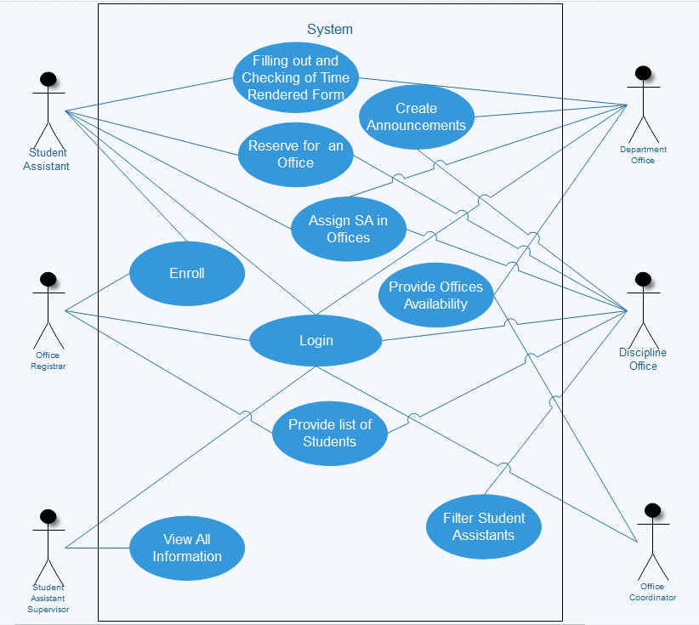

**Use Case Full Description**

